# **Pizza Sales SQL Queries**

**A.KPI’s**

**1. Total Revenue:**

SELECT SUM(total_price) AS Total_Revenue FROM pizza_sales;

**2. Average pizza value by order:**

SELECT (SUM(total_price) / COUNT(DISTINCT order_id)) AS Avg_order_Value FROM pizza_sales;



**3. Total Pizza sold:**

SELECT SUM(quantity) AS Total_pizza_sold FROM pizza_sales;



**4. Total Orders:**

SELECT COUNT(DISTINCT order_id) AS Total_Orders FROM pizza_sales;



**5. Average Pizza per Order:**

SELECT CAST(CAST(SUM(quantity) AS DECIMAL(10,2)) /

CAST(COUNT(DISTINCT order_id) AS DECIMAL(10,2)) AS DECIMAL(10,2))

AS Avg_Pizzas_per_order

FROM pizza_sales;



**B. Daily Trend of Order:**

SELECT DATENAME(DW, order_date) AS order_day, COUNT(DISTINCT order_id) AS total_orders

FROM pizza_sales

GROUP BY DATENAME(DW, order_date);

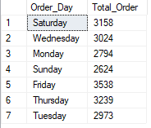

**C. Monthly trend for total orders:**

select DATENAME(MONTH, order_date) as Month_Name, COUNT(DISTINCT order_id) as Total_Orders

from pizza_sales

GROUP BY DATENAME(MONTH, order_date);

**D. Percentage of sales by Pizza category:**

SELECT pizza_category, CAST(SUM(total_price) AS DECIMAL(10,2)) as total_revenue,

CAST(SUM(total_price) * 100 / (SELECT SUM(total_price) from pizza_sales) AS DECIMAL(10,2)) AS PCT

FROM pizza_sales

GROUP BY pizza_category;

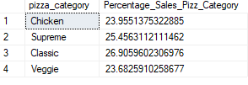

**E. Percentage of sales by Pizza size:**

SELECT pizza_size, CAST(SUM(total_price) AS DECIMAL(10,2)) as total_revenue,

CAST(SUM(total_price) * 100 / (SELECT SUM(total_price) from pizza_sales) AS DECIMAL(10,2)) AS PCT

FROM pizza_sales

GROUP BY pizza_size

ORDER BY pizza_size;

**F. Total Pizzas Sold by Pizza Category:**

SELECT pizza_category, SUM(quantity) as Total_Quantity_Sold

FROM pizza_sales

WHERE MONTH(order_date) = 2

GROUP BY pizza_category

ORDER BY Total_Quantity_Sold DESC

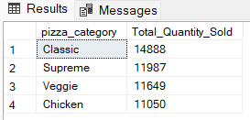

**G. Top 5 Pizzas by Revenue:**

SELECT Top 5 pizza_name, SUM(total_price) AS Total_Revenue

FROM pizza_sales

GROUP BY pizza_name

ORDER BY Total_Revenue DESC;

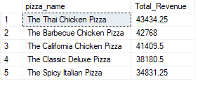

**H. Bottom 5 Pizzas by Revenue:**

SELECT Top 5 pizza_name, SUM(total_price) AS Total_Revenue

FROM pizza_sales

GROUP BY pizza_name

ORDER BY Total_Revenue ASC

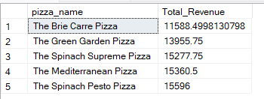

**I. Top 5 Pizzas by Quantity:**

SELECT Top 5 pizza_name, SUM(quantity) AS Total_Pizza_Sold

FROM pizza_sales

GROUP BY pizza_name

ORDER BY Total_Pizza_Sold DESC;

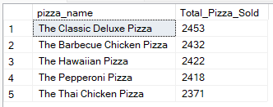

**J. Bottom 5 Pizzas by Quantity:**

SELECT TOP 5 pizza_name, SUM(quantity) AS Total_Pizza_Sold

FROM pizza_sales

GROUP BY pizza_name

ORDER BY Total_Pizza_Sold ASC;

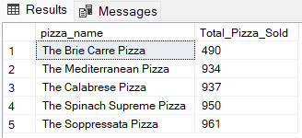

**K. Top 5 Pizzas by Total Orders:**

SELECT Top 5 pizza_name, COUNT(DISTINCT order_id) AS Total_Orders

FROM pizza_sales

GROUP BY pizza_name

ORDER BY Total_Orders DESC;

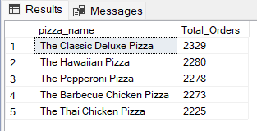

**L. Bottom 5 Pizzas by Total Orders:**

SELECT Top 5 pizza_name, COUNT(DISTINCT order_id) AS Total_Orders

FROM pizza_sales

GROUP BY pizza_name

ORDER BY Total_Orders ASC;

